Cleaning out your Fuel Injectors and Tank – and other tips!
For this job you need a selection of Hex-keys, a 10mm socket, a teensy drop of engine oil (for reassembly) and a large aerosol can of carb cleaner. I'd suggest you allow 30 mins - 1 hour to do the job.

- Remove the tank (helps if it's nearly empty) by removing the 2 x 10mm bolts at the rear. Lift and wedge up such that you have both hands free to unclip the power feed (clear plug) and the fuel line from the fuel rail (squeeze the 2 grey clips together and pull away from rail – it’s often a bit stiff at first).
- Place your tank upside-down on a clean blanket/mat/rag, so as not to scratch or swirl the paint.
- You will see 2 large removable disks, both with wires and tubes. We're interested in the big one that's closer to the center for this job - that's also the one that pokes out from the base of the tank, not the flush mounted piece. This is the housing for the pump

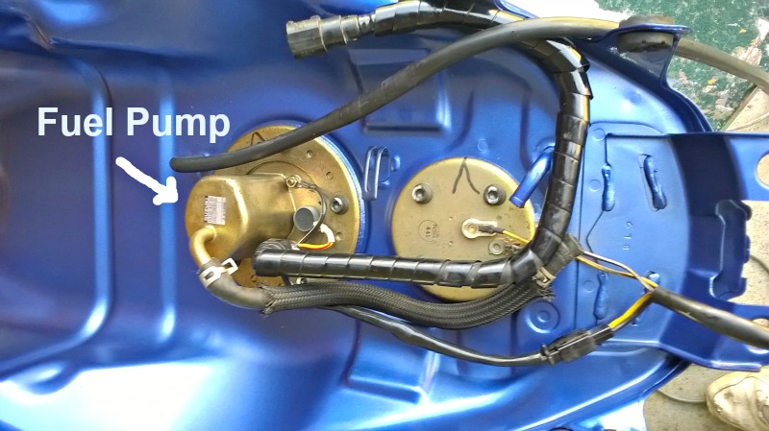

- Disconnect the power coupling that links the two discs/panels together. Remove the black tubes (fuel line and other one). Then remove the 5 hex bolts that hold the unit into the tank.
- Slide the unit out carefully. Might be good to have an old bowl around as there's going to be some splashes of fuel that are still inside as you dismantle. What you're now holding is a metal base, with the pump and filter screwed into it.
- Look for the 2 gold coloured screws either side and remove them. Then undo the nut that earths the pump to the base. Hold the pump and base, then pull apart. This takes some force as the o-rings are tight, but they will slide apart as long as the screws were removed first. Once apart you will see a 'plastic tea-bag' type thing on the base of the pump... this is the 'low pressure filter' and it's probably covered in rust/gunge.
- Look inside the bottom of the bowl, check it's not rusted. If it is you must clean this out well. I used acid, flushed it well, then emery to refinish. Ideally it should be re-plated.
- Pull the low-pressure filter away from the base of the pump (the holder unclips, the [plastic tube isn't removable, use carb cleaner to back-flush and clean it up.
- Look at the pump/black plastic filter now. Remove the white clip from the top, then pull the metal pressure release valve/silver top hat away from the black plastic. Again, it's tight, but it will come loose. Flush this with carb cleaner.
- Pull the pump (metal cylinder) away from the black plastic contraption (high pressure filter). Use most of the can to back flush and flood this high pressure filter, shaking as you go to release all the crap. At the end you should be able to blow through this and feel no resistance.
- Ensure parts are emptied of carb-cleaner (a few drops doesn't matter though as it's designed to be used in running engines) then re-assemble, and use that dab of oil on the 2 fat o-rings (release valve and base). This makes it possible to get them in without risking damage. Damage or forget these and you will not be able to start the bike. Ensure everything's fully pushed home as you go, to prevent pressure leaks.
- Look at the fuel rail (metal bar that the fuel line couples to) and the injectors (the orange things, with the fuel rail to their rear. Remove them - 2 screws to the rear hold the fuel rail in place, you'll need to cut the cable-ties, and removing the chromed-plastic injector shrouds first helps.
- The injectors simply push into the fuel rail and intake manifolds. Pull the rail back and pull the injectors out. Make sure you don't lose the o-rings/rubber cushions as you do so. Inspect the fuel rail for crap, then blow the fuel rail clean with carb cleaner.
- Blow out the rear entry of the injectors with carb cleaner - I kept mine on the bike, and cranked the starter after each had a dousing so it got into the workings. Repeat twice.
- Reassemble, using engine oil on the o-rings to fit the injectors back into the fuel rail. Refit tank, remembering to connect all the hoses, and power couplings back together.

Note the sequence for tightening the pump bolts

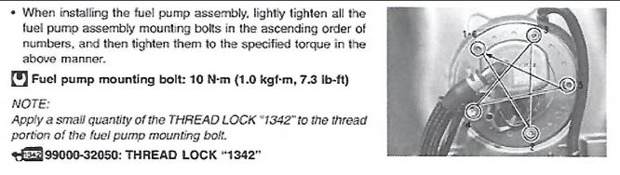

- Ignition on, wait and listen. You should hear the pump pressurize and then a very gentle high whine that stays for a while. Wait and check you don't hear anything else, like things popping off inside the tank, or see any leaks around the injectors as they run at high pressure.
- Provided your bike is not covered in petrol because you got something wrong, start her up. She should sound better and the throttle will give a more instant/crisp response, with more power on tap.
- Take for short test ride, and check all connections etc. for leaks upon your return.

A few notes:
- Over time your injectors may gum up with fuel residue, giving the appearance of rough or lumpy running (not the only cause, but can be one of the causes). Whilst the above procedure can help, it is no substitute for getting your injectors professionally cleaned using ultrasonic methods (these companies will clean them and provide before and after fuel flow rates). It is worthwhile trying this first before replacing injectors with new ones (much cheaper as well). Check recommended suppliers in this forum for details
- If you want to clean the tank, you need to decide (or determine) why it needs cleaning
  - If you just want to flush it out as a matter of routine you could do that with petrol or a nice strong solvent - any carb cleaner is going to be ideal at shifting a build-up of tank scum.
  - If you have spotted rust in there then head for www.frost.co.uk. They do products like marine clean or even full tank sealing kits.
Just remember to wash any strong cleaning product out with petrol, before you replace the tank and run the bike
- Be careful when you replace the filter & pump assembly into the base plate - just pushing it in slowly with the O-ring correctly located cracked my new stupidly expensive filter. Araldite seems to have solved it (and is claimed to be petrol safe).
- One other option to taking the pump apart is to reverse flush the filters with acetone. Whilst the pump is out, reverse the polarity on the pump - often dirty black gunk will come out the other end. Continue doing this until you can easily blow through it again (note this can take a number of flushes to achieve).
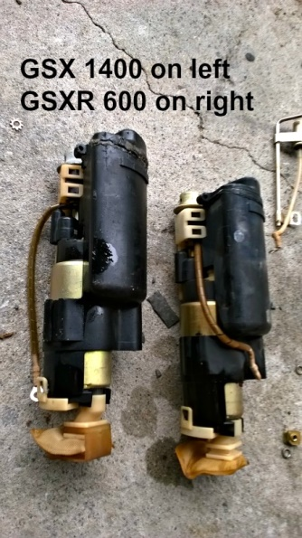
- Rather than clean the filter – or if your pump is cactus, you might want to (or need to) replace it. Sourcing a good (or even any) replacement GSX1400 pump is hard – in fact you will probably have difficulty in finding one, and even then, will be charged a small fortune. New they are not cheap either from Suzuki themselves. Others who have been in this position have found that pumps off the GSXR750 K2-K4 are the same (all you have to do is change the base plate to the one you take out of your 14), or one off a GSXR600 K2-K4 (you may have to change the baseplate on that as well)

- Another worthwhile mod to your pump whilst you have it out is to secure the regulator clip (arrowed in picture below), as this has been known in the past to either ping off or break, bringing your machine to a standstill. To help prevent this happening twist some stainless welding wire as a safety lock around the pump together with the clip to both provide support and take some tension off the clip itself (some others have electrical ties instead, this works as well, but do check first that the tie will not dissolve in petrol!)
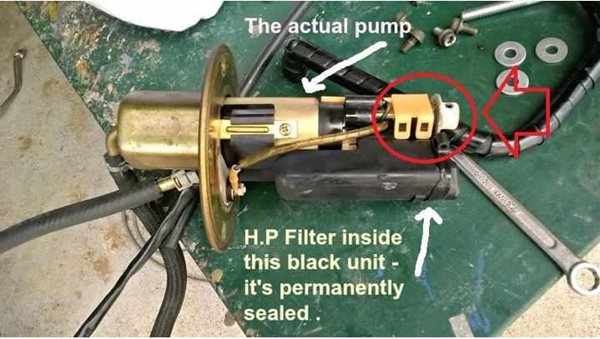
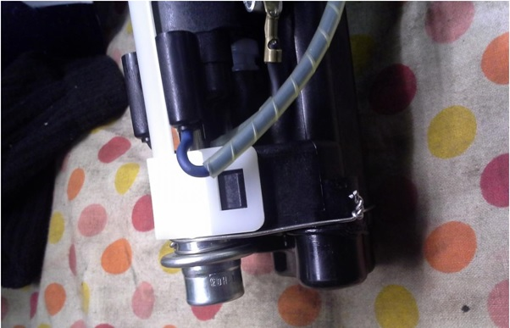

- Finally for those unsure what the “tea bag” looks like (that we’ve been talking about in this article)….



