Open your photo using PAINT, and click on RESIZE
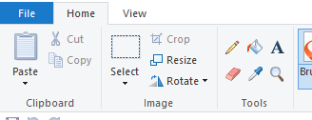

This will give this pop-up. Click on Pixels and put in 1024 for Horizontal. Press OK, then save your picture as a .jpg file (renaming if necessary, else you will lose the size of the original)

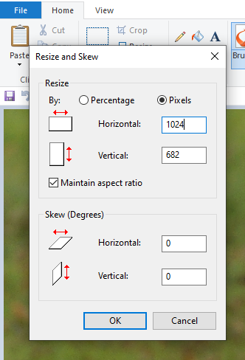

That’s it – picture re-sized! Now for uploading to the forum.

Open the thread and type the words you want. In the bottom LH corner of an open thread, you will see “Attachments and other options”. Click on that.
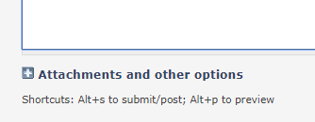

This will then show this extended pop-up. Under attach, click on Choose File and select the photo you just re-sized.



